Title Title Title Title Title Title Title Title Title Title Title Title Title Title Title Title Title Title Title Title Title Title Title

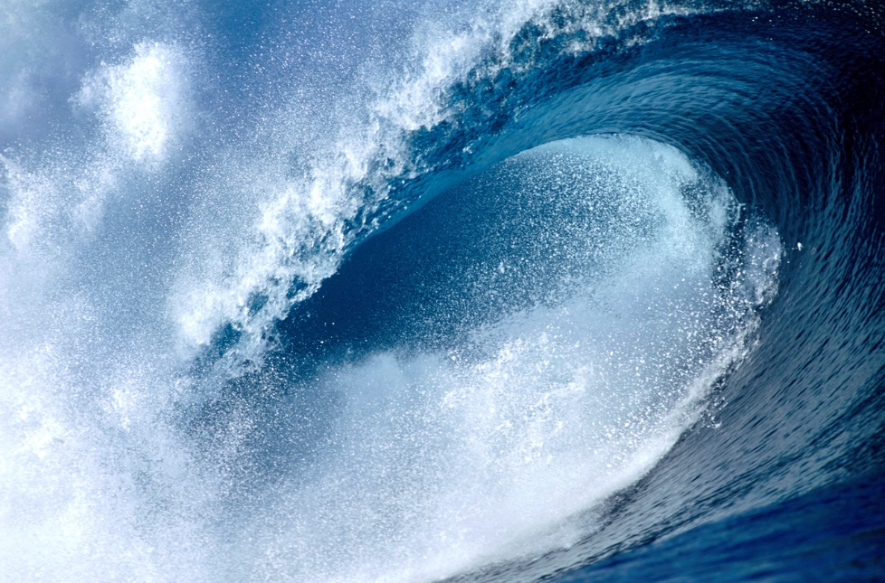

Type of Report

Presented by
FirstName LastName

Supervised by
FirstName LastName
Date

Table of Contents
Table of Contents 3
1 Introduction 4
2 Theory 5
2.1 Heading 2 5
2.1.1 Heading 3 5
2.1.1.1 Heading 4 5
3 Tasks and Methods 6
4 Results and Discussion 7
5 Conclusion and Outlook 8
6 References 9

Introduction
The first chapter has three purposes
- What are the challenges? Why is this work needed?
- (State-of-the art. Give key citations.)
- What are the results offered by this work? To what extent have the challenges been tackled by this P+S. Summarize the key results.
Text text text text text text text text text text text text text text text text text text text text text text text text text text text text text text text text text text text text text text text text text text text text text text text text text text text text text text text text text text text text text text text text text text text text text text text text text text text text text:
- Text text text text text text text text text text text text text text text text text text text text text text text text text text text text text text text text text.
- Text text text text text text text text text text text text text text text text text text text text text text text text text text text text text text text text text text text text text text text text text text text text text text text text text text.
- Text text text text text text text text text text.
Text text text text text text text text text text text text text text text text text text text text text text text text text text text text text text text text text text text text text text text text text text text text text text text text text text text text text text text text text text text text text text text text text text text text text text text text text text text text text:
- Text text text text text text text text text text text text text text text text text text text text text text text text text text text text text text text text text.
- Text text text text text text text text text text text text text text text text text text text text text text text text text text text text text text text text text text text text text text text text text text text text text text text text text text.
- Text text text text text text text text text text text text text text text text text text text text text text text text text text text text text text text text text.
- Text text text text text text text text text text.
- Text text text text text text text text text text.
- Text text text text text text text text text text.
- Text text text text text text text text text text.
- Text text text text text text text text text text.
- Text text text text text text text text text text.
- Text text text text text text text text text text.
- Text text text text text text text text text text.
Text text text text text text text text text text text text text text text text text text text text text text text text text text text text text text text text text text text text text text text text text text text text text text text text text text text text text text text text text text text text text text text text text text text text text text text text text text text text text.

Theory
Very briefly explain the theory behind your work and discuss the key parameters that have to be optimized. This chapter will allow a reader in the field to read the next chapters without looking up books. Key results and derivations are given. The theory may be derived from literature – but proper citing is expected. The material however has to be made up in a consistent way and a common nomenclature has to be used throughout the report.
Text text text text text text text text text text text text text text text text text text text text text text text text text text text text $\frac{f^{f}}{f^{f}}$ text text text text text text text text $\sum_{i=1}^{n}{x^{i}}$ text text text text text text text text text text text text text text text.
 | $$\sum_{i=1}^{n}{x^{i}}$$ | (2.1)
Text text text text text text text text text text text text $\sum_{i=1}^{n}{x^{i}}$ text text text text text text text text text text text text text text text.
 | $$\int{\sin{x}}dx=-\cos{x}+C$$ | (2.2)
 | $$2+3=5$$ | (2.3)

Heading 2
Text text text text text text text text text text text text text text text text text text text text text text text text text text text text $\frac{f^{f}}{f^{f}}$ text text text.
 | $$\sum_{i=1}^{n}{x^{i}}$$ | (2.4)

Heading 3
Text text text text text text text text text text text text text text text text text text text text text text text text text text text text $\frac{f^{f}}{f^{f}}$ text text text.
 | $$\sum_{i=1}^{n}{x^{i}}$$ | (2.5)
Text text text text text text text text text text text text text text text.

Heading 4
Text text text text text text text text text text text text text text text text text text text text text text text text text text text text $\frac{f^{f}}{f^{f}}$ text text text text text text text text text text text text text text text text text text text text text text text text text text text text text text text text text text $\sum_{i=1}^{n}{x^{i}}$ text text text text text text text text text text text text text text text, see (2.5).

Tasks and Methods
Guide the audience through the tasks of your work (simulations, measurements, analysis, etc.) and briefly discuss the methods explored.
Text text text text text text text text text text text text text text text text text text text text text text text text text text text text $\frac{f^{f}}{f^{f}}$ text text text text text text text text text text text text text text text text text text text text text text text text text text text text text text text text text text $\sum_{i=1}^{n}{x^{i}}$ text text text text text text text text text text text text text text text.
Text text text text text text text text text text text text text text text text text text text text text text text text text text text text $\frac{f^{f}}{f^{f}}$ text text text text text text text text text text text text text text text text text text text text text text text text text text text text text text text text text text $\sum_{i=1}^{n}{x^{i}}$ text text text text text text text text text text text text text text text.

Results and Discussion
This chapter comes with results. Explain the reader how you performed your simulations. Show your simulated results and compare them to what you expected. Explain what is learnt/achieved with these experiments and explain the gravity of your findings.
Text text text text text text text text text text text text text text text text text text text text text text text text text text text text $\frac{f^{f}}{f^{f}}$ text text text text text text text text text text text text text text text text text text text text text text text text text text text text text text text text text text $\sum_{i=1}^{n}{x^{i}}$ text text text text text text text text text text text text text text text, see Fig. 4.1.
Fig. 4.1: Caption caption caption caption caption caption caption caption caption caption caption caption caption caption caption caption caption caption caption caption caption caption caption caption caption caption caption caption caption caption caption caption caption caption.
Text text text text text text text text text text text text text text text text text text text text text text text text text text text text $\frac{f^{f}}{f^{f}}$ text text text text text text text text text text text text text text text text text text text text text text text text text text text text text text text text text text $\sum_{i=1}^{n}{x^{i}}$ text text text text text text text text text text text text text text text, see Table 4.1.
 | Text | Text | Text
Text | Text | Text | Text
Text | Text | Text | Text
Text | Text | Text | Text
Text | Text | Text | Text
Table 4.1: Caption

Conclusion and Outlook
Summarize the P+S. Give results and give numbers as to what has been achieved.
Vision – tell the bigger vision of what might come next and how the world is going to change if the results are realized .
Text text text text text text text text text text text text text text text text text text text text text text text text text text text text text text text text text text text text text text text text text text text text text text text text text text text text text text text text text text text text text text text text text text text text text text text text text text text text text.
Text text text text text text text text text text text text text text text text text text text text text text text text text text text text text text text text text text text text text text text text text text text text text text text text text text text text text text text text text text text text text text text text text text text text text text text text text text text text text text text text text text text text text text text text text text text text.
Text text text text text text text text text text text text text text text text text text text text text text text text text text text text text text text text text text text text text text text text text text text text text text text text text text text text text text text text text text text text text text text text text text text text text text text text text text text text text.
Text text text text text text text text text text text text text text text text text text text text text text text text text text text text text text text text text text text text text text text text text text text text text text text text text text text text text text text text text text text text text text text text text text text text text text text text text text text text text text text text text text text text text text text text text text text text.
Text text text text text text text text text text text text text text text text text text text text text text text text text text text text text text text text text text text text text text text text text text text text text text text text text text text text text text text text text text text text text text text text text text text text text text text text text text text text text text text text text text text text text text text text text text text text.
Text text text text text text text text text text text text text text text text text text text text text text text text text text text text text text text text text text text text text text text text text text text text text text text text text text text text text text text text text text text text text text text text text text text text text text text text text text text text text.
Text text text text text text text text text text text text text text text text text text text text text text text text text text text text text text text text text text text text text text text text text text text text text text text text text text text text text text text text text text text text text text text text text text text text text text text text text text text text text.

References
[1] G. P. Agrawal, Fiber-optic communication systems, 2nd ed. New York, N.Y.: Wiley, 1997.
[2] W. H. Press, Numerical recipes in C the art of scientific computing, Second ed. Cambridge etc.: Cambridge University Press, 1999.
[3] S. V. Kartalopoulos, DWDM networks, devices, and technology. Piscataway, NJ: IEEE Press, 2003.
[4] A. Leon-Garcia and I. Widjaja, Communication networks fundamental concepts and key architectures. Boston, Mass.: McGraw-Hill, 2000.
[5] F. Frhr. v. Loeffelholz, "Pionier der Informationstheorie Claude Elwood Shannon," c't - Magazin für Computertechnik, vol. 6/2001, 2001.
[6] P. J. Winzer, "Modulation and Multiplexing in Optical Communications," in Conference on Lasers and Electro-Optics/International Quantum Electronics Conference, Baltimore, Maryland, 2009, p. CTuL3.
[7] W. Freude, R. Schmogrow, D. Hillerkuss, J. Meyer, M. Dreschmann, B. Nebendahl, et al., "Reconfigurable optical transmitters and receivers," 2012, pp. 82840A-82840A-8.
[8] Twisted-Pair-Kabel. Available: http://de.wikipedia.org/wiki/Twisted-Pair-Kabel
[9] Kabel - nicht nur für den Computerbau wichtig. Available: http://www.hardware-bastelkiste.de/index.html?cable.html#TP%E2%80%9C
[10] A. Leon-Garcia and I. Widjaja, "Twisted Pair," in Communication networks fundamental concepts and key architectures, ed Boston, Mass.: McGraw-Hill, 2000, p. 148.
[11] T. Kremp and W. Freude, "DWDM transmission optimization in nonlinear optical fibres with a fast split-step wavelet collocation method," in 7th International Conference on Optoelectronics, Fiber Optics & Photonics (Photonics), Kochi, India, 2004.
[12] R.-J. Essiambre, G. J. Foschini, P. J. Winzer, and G. Kramer, "Capacity limits of fiber-optic communication systems," in Proc. Opt. Fiber Commun. Conf., San Diego, CA, 2009.
[13] Video broadcasting technology. Available: http://www.epanorama.net/links/videobroadcasting.html
[14] High-definition television. Available: http://en.wikipedia.org/wiki/High-definition_television
[15] P. Qu and C. Polley. (2005). The New Standard-Bearer: China is now trying to set the rules for many developing technologies. Available: http://spectrum.ieee.org/computing/hardware/the-new-standardbearer
[16] D. Santa-Cruz and T. Ebrahimi, "A study of JPEG 2000 still image coding versus other standards," Proc. of the X European Signal Processing Conference, vol. 2, pp. 673-676, 2000.

